BSCS FINAL PROJECT
Rapid Rescue



Project Advisor

Asif Farooq

Presented by:

Group ID: F24BS044

Student Reg# Student Name
L1F21BSCS1039 | TALHA JAVED
L1S21BSCS0105 | FAHEEM KHAN
L1F21BSCS1214 | JAWAD AHMAD

Faculty of Information Technology

University of Central Punjab
Software Requirements Specification
Version 1

Rapid Rescue
Advisor: Asif Farooq

Group F24BS044
Member Name | Primary Responsibility
Faheem Khan | All Work Done Equally
Talha Javed | All Work Done Equally
Jawad Ahmad | All Work Done Equally

Table of Contents
Table of Contents i
Revision History ii
Abstract iii
1. Introduction and Background 1
1.1 Product (Problem Statement) 1
1.2 Background 1
1.3 Scope 2
1.4 Objective(s)/Aim(s)/Target(s) 2
1.5 Challenges 2
1.6 Learning Outcomes 2
1.7 Nature of End Product 3
1.8 Completeness Criteria 3
1.9 Business Goals 3
1.10 Related Work/ Literature Survey/ Literature Review 4
1.11 Document Conventions 4
2. Overall Description 4
2.1 Product Features 4
2.2 User Classes and Characteristics 5
2.3 Operating Environment 6
2.4 Design and Implementation Constraints 6
2.5 Assumptions and Dependencies 6
3. Functional Requirements 7
3.1 Name of Use-Case 1 8
3.2 Name of Use-Case 2 (and so on) 13
3.3 Requirements Analysis and Modeling 13
4. Nonfunctional Requirements 19
4.1 Performance Requirements 19
4.2 Safety Requirements 19
4.3 Security Requirements 20
4.4 Additional Software Quality Attributes 20
5. Other Requirements 20
6. Revised Project Plan 21
7. References 22
Appendix A: Glossary 22
Appendix B: IV & V Report 23

Revision History
Name | Date | Reason For Changes | Version

Abstract
The traditional method of Road accident reporting relies on citizen calls, often resulting in delays in emergency response. So, to eliminate critical delays in emergency response and improve the efficiency of ambulance services, our project introduces an innovative system utilizing traffic cameras to detect traffic accidents and send alerts to the nearest ambulance services. Upon detection, the system notifies the closest ambulance services of the accident, ensuring a rapid response.

Our project, Rapid Rescue, is based on artificial intelligence merged with video streams to recognize the accident. This is followed by notification to ambulances about the accident, its location, and the way of getting to the accident location. This ensures that it has accuracy, thus improving the emergency services of urban areas and saving people's lives.

Computer vision algorithms analyze video feeds from strategically placed cameras to identify accidents. In addition to the detection and notification system, an application will feature a management dashboard for ambulance services. This dashboard will store accident location data.

.

Introduction and Background
Whenever an accident occurs on roads, most existing emergency systems are slow to respond due to a high reliance on manual reporting. These delays have a significant impact on the timely arrival of ambulances, which can lead to an increase in the number of deaths and serious injuries in areas with high traffic volumes, where accidents occur frequently. Currently, there are no public systems in Punjab that can detect accidents and provide immediate, detailed information to emergency first-aid responders and ambulances. There is an urgent need for intelligent systems that can quickly detect accidents, generate alerts, shorten response times, and transmit information to nearby ambulances to improve the efficiency of emergency services. Our system will use artificial intelligence to automate accident detection for improved response times.

Product (Problem Statement)
The current emergency response systems are suffering from serious delays, largely due to the reliance on manual reporting of accidents. In most cases, such delays cause a difference between life and death. For this reason, urban centers are marred by congestion, inefficient communication in most settings, and lack of real-time insight into accidents, frustrating efforts to get ambulances to accident scenes on time. These inefficiencies underscore the urgent need for an accident detection system and accurate, actionable data for services that save precious response time. Our product “Rapid Rescue” responds to the critical problem of delayed emergency response. As a result, it optimizes dispatch operations to minimize response times and save lives.

Background
Emergency response systems form an important part of urban infrastructure. It is supposed to save human lives in cases of accidents, but most of the current systems are incompetent, primarily due to inefficiencies in the reporting and dispatching of ambulances. These mainly arise due to an overwhelming dependence on manual processes that may delay the detection and response to accidents.
With advancements in technology, artificial intelligence has emerged as a powerful tool for improving emergency services. AI-driven systems can automate accident detection, reducing dependency on human intervention, while real-time analytics enable communication with ambulance services.
Having studied the limitations of traditional systems and considered state-of-the-art technologies, we suggest ‘Rapid Rescue” as an innovation in this regard. This product uses AI and computer vision to detect traffic accidents from video feeds, ensuring immediate alerts and dispatch routes for ambulances.
Rapid Rescue builds on existing research in intelligent traffic systems and real-time analytics to identify gaps, such as computer vision with real-time ambulance dispatch and geolocation services. This project will contribute to more efficient and life-saving responses in an emergency system that is fit for urban environments.

Scope
Rapid Rescue's scalable and AI-driven system transforms emergency response in urban areas by eliminating the lag involved with dispatching ambulances. It uses video analytics to automatically detect road accidents and feeds the location with precision to the accessible ambulances. This system is scalable for deployment across urban centers and supports real-time monitoring, thus ensuring higher efficiency in terms of response and in alignment with smart city initiatives that also improve public safety.

This service-oriented system perfectly meshes with existing frameworks. Emergency operators, along with urban planners, can use the system to increase response rates and gain information regarding trends in accidents.

Objective(s)/Aim(s)/Target(s)
- Build an AI system for real-time accident detection.
- Real-time communication for optimized ambulance dispatch
- Provide a dashboard for stats and analysis​

Challenges
- Knowledge of computer vision algorithms for accurate real-time identification of accidents.
- Integration with multiple APIs for enabling communication and mapping.
- Data management and low-latency communication for real-time alerts​.
- Implement analytics to improve ambulance deployment strategies and generate reports on accident trends.

Learning Outcomes
We will become proficient in implementing fine-tuning algorithms for video analysis, gaining valuable experience designing and optimizing systems capable of processing data with minimal latency. By integrating APIs, we will become adept at using these tools to create seamless, multi-functional applications. Additionally, we will develop an understanding of web development frameworks, gaining experience in building responsive, user-friendly web applications with dashboards and data visualization tools. We will also learn how to use WebRTC for real-time video streaming, setting up, configuring, and optimizing video streams. Throughout the project, we will enhance our ability to document our work and present our findings, preparing us for future professional environments where clear communication of technical details is crucial.

Nature of End Product
The final product will be a scalable system designed to detect traffic accidents. This system addresses key issues related to detection accuracy and deployment feasibility. By setting a threshold for accident detection, the model minimizes false positives, ensuring that alerts are only triggered by significant collisions rather than minor incidents. This approach is crucial for maintaining the reliability of emergency response systems and preventing unnecessary dispatches.

Our system is designed as a service-oriented solution, meaning we are focused solely on developing and selling the detection and alerting system itself. We are not concerned with the infrastructure of the end-user environment or how it will be implemented within specific operational frameworks. Once sold, the system will be seamlessly integrated into any firm’s existing infrastructure. The dashboard component allows ambulance services to analyze data, optimizing their response strategies without requiring further involvement from us.

Completeness Criteria
S No. | Criteria | Weightage %
1 | Computer Vision Algorithm and Detection Accuracy | 40
2 | Real-time alert System | 20
3 | Dashboard and Data Analytics | 25
4 | API and Cloud Integration | 15

The project will be achieved when the AI has accurate in real-time accident detection, the communication platform has minimum latency, and the dashboard shows data properly.

Business Goals
Minimize Emergency Response Times:
Cut down the ambulance time-to-accident scene using real-time AI-based accident detection.

Accuracy in Accident Detection:
Real-time video analytics and Artificial Intelligence powered it results in better detection accuracy as well as reducing false positives.

Data-Driven Decision-Making Facilitation:
An analytics dashboard offering review of the responses, allowing ambulance services to make improvements.

Easy Integration:
It is worth developing a service-oriented approach that can integrate into the emergency framework offered by frameworks using APIs, thus minimal overhaul at the user end.

Related Work/ Literature Survey/ Literature Review
- Kamran and Haas (2007) present a multilevel approach using GPS data.
- Škorput et al. (2012) propose a real-time detection system based on road traffic incidents.
- Ksiksi et al. (2015) focused on intelligent traffic alert systems in smart cities.
- Sadaphal (2019) developed an Android-based detection and alert system.

While these works contribute to real-time incident management, none fully integrate computer vision with real-time video feeds and ambulance dispatch systems.

Document Conventions
The fonts and size that we have used in this documentation vary from topics and discussions. The types of words that are represented this way include the following:
Font: Times New Roman
Font size: 12
Line spacing: 1.15

Overall Description

2.1 Product Features
The major features of the Rapid Rescue system include:

Accident Detection:
- Analyzing live videos feeds from road cameras using computer vision algorithms.
- Able to detect traffic accidents.

Real-Time Alerts and Notifications:
- Sends automatic instant alarms to the neighboring ambulances and dispatch centers in case of an accident.
- Proposed optimal way of travel using APIs like Google Maps.
- Co-ordinates of the exact place of the accident.

Analytics Dashboard:

- Drawing charts displaying the trend of incidents like, time rate of accidents and number of accidents throughout a time.
- Time parameters when using response time as a measure of dispatch effectiveness.
Cloud Integration:
- Running on the cloud on service platforms like AWS with potential for scalability in terms of processing.
- API guarantees integration with other systems for mapping, for instance, Google Maps, communication and management of ambulance.

User Classes and Characteristics
1. Ambulance Drivers:
Role: Respond to the incidents and then plot to the location of accidents using best routes.
Key Features: Notification options that include the location, route consideration of the presence of traffic.
Characteristics:
- Proficiency in the use of mobile phones, primarily in navigation (GPS system).
- Trained to use the interface and utilize systems features effectively.

2. City Traffic Management Authorities:
Role: Supervise traffic flow, calamity contingencies, and interests that relate to policy.
Key Features:
- Long-term analysis of incident.
- Generate reports on traffic incidents and emergency response performance.
Characteristics:
- Decision makers worked on travelling distance for route optimization by using collective insights.
- Desires export capabilities for reports and has the need for custom dashboard.
- Interact with interface less frequently, primarily for analysis.

3. System Administrators:
Role: Performing maintenance on the software, changing and updating rights of the users, and including new features.
Key Features: It includes:
- Backend management
- User access and management of permission.
- Encryption for data privacy.
Characteristics:
- Advanced technical knowledge in cloud systems, APIs, and AI frameworks.
- Focused on system maintenance, with less frequent but critical interactions.

Operating Environment
High-definition cameras with live video capabilities, servers housed in the cloud using GPUs for AI processing, along with ambulance mobile devices to let the crews receive alerts, are necessary to the system. For hosting and scalability, it runs on web scale architectures like AWS, Google Cloud, etc., and for the analytics dashboard it runs web scale tools for popular browsers like Google Chrome and Firefox. It consists of application software and libraries for using TensorFlow, PyTorch, OpenCV for accident detection; WebRTC for live video broadcasts; cloud messaging services for notifications, such as Twilio and Firebase; and mapping tools like that of Google Maps or OpenStrteetMap for route optimization. Sustainable bandwidth connection over real time video streaming and data transmission system and contingency measures to continue operation during power failure or other disruption is a dependence on.

Design and Implementation Constraints
Regulatory Policies:
To protect user's privacy and data, the system will have to comply with the existing data protection laws as well as those that are anticipated in Personal Data Protection Bills. Video streams need to be collected and processed in public space and permission may be required. Conditions of use and storage of video feed can be dictated by entities such as NADRA, provincial traffic departments or any other body that lays down the surveillance restrictions. Moreover, actual use of video storage duration must comply with applicable legal regulations.

Hardware Limitations:
However, hardware limitations such as low quality of many of Pakistan’s road cameras (especially in rural areas) lacking high-definition capabilities complicate the system. In some areas, camera functionality may be limited if persistent power failures make the cameras suffer from adverse effects. The absence of locally hosted data centers may prevent real-time performance and, as an example, using AWS or Azure as an international cloud service, gives you higher latency. If integrated in large scale services such as Microsoft Azure Pakistan, then that would minimize latency issue. Local development services such as this: TPL Maps (for example) may provide more accurate geolocation data for Pakistani roads than Google Maps API standards might require. Also, AI models need to be developed for recognizing accidents in traffic conditions particular to Pakistan, including traffic flow which is mixed with motorcycle, rickshaw, and bus.

Programming Standards:
Modern frameworks and libraries like TensorFlow and PyTorch should be used by the system to avoid creating incompatibility with infrastructure resource constraints. At the same time, considering the speeds of rapid city development, with increased system demands and further video streams to major cities such as Lahore, Karachi, respectively, it must be designed for scalability.

Assumptions and Dependencies
Assumptions:
Broadband comes through in big cities, but the bandwidth can be awful in small towns. Traffic management authorities such as City Traffic Police provide a road camera that are online and searchable. Dispatchers, drivers, and traffic management officials are minimally technically proficient but on par with what is required to navigate the dashboard and be alerted. There is government support, with authorities like traffic, Ambulance services such as Rescue 1122 ready to work together and share technology and assets.
Dependencies:
To do that it needs a system to use APIs like Maps for good geolocation and traffic conditions; platforms like WhatsApp matter in Pakistan playing the role of distributing these alerts. Local traffic videos should be provided by the Pakistani government and the training datasets should include videos of multi vehicle collision, high density traffic, and specially conditioned upon the region. To get the needed data you should collaborate with universities or research institutions. Pilot implementation and data collection require local partnerships with the private and public ambulance services, Rescue 1122, and the Punjab Safe Cities Authority. Jazz and Telenor should be engaged to provide latency free communication in remote areas. For data sovereignty and latency reasons we prefer cloud hosting at local or regional data centers. Furthermore, to assure energy trustworthiness in the situation of energy outages, secondary measures, as well as UPS systems, or solar batteries should be installed.

Functional Requirements
Use Case diagram
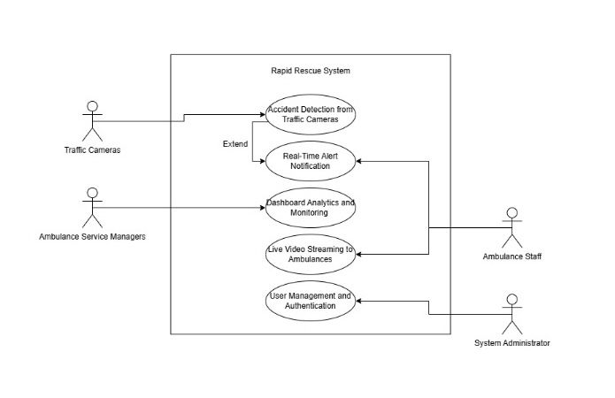

Accident Detection from Traffic Cameras
Identifier |  | UC-1
Purpose |  | Real time detection (based on video feeds from traffic cameras) of traffic accidents
Priority |  | High
Pre-conditions |  | The cameras must be working, live streaming.  The AI model needs to be pushed to the edge and active.
Post-conditions |  | The accuracy of the system in detecting accidents is high.  The dashboard and the ambulance dispatch system are alerted to detected accidents.
Typical Course of Action
S# | Actor Action |  | System Response
1 | Video streams live through traffic cameras. |  | The video feed is analyzed in real time for content by system.
2 | AI detects an accident. |  | The event is logged and decided on severity.
3 | System generates an alert. |  | The dashboard and the nearest ambulances are alerted to an alert.
Alternate Course of Action
S# | Actor Action |  | System Response
1 | Ambulances are unreachable. |  | Communication will be retried by the system or alert escalated to a backup supervisor.
2 | Multiple ambulances respond. |  | System coordinates responses to avoid duplication of the work.
Table 1: UC-1

Real-Time Alert Notification
Identifier |  | UC-2
Purpose |  | To send real time alerts to nearby ambulances with accident details.
Priority |  | High
Pre-conditions |  | It has detected accident.  Areas with ambulance services are registered and can be contacted.
Post-conditions |  | In telling ambulances exactly the precise accident details; including the location and severity.  It responds promptly.
Typical Course of Action
S# | Actor Action |  | System Response
1 | AI detects an accident. |  | Location and severity details are retrieved by the system.
2 | The system identifies nearby ambulances. |  | With all the necessary details, the nearest ambulances are notified.
3 | Ambulance staff confirm response. |  | It confirms logs and updates dashboard.
Alternate Course of Action
S# | Actor Action |  | System Response
1 | Ambulances are unreachable. |  | Communication is retried by the system, or an alert to a backup trail is raised.
2 | Multiple ambulances respond. |  | Try to avoid duplication by using system.
Table 2: UC-2

Dashboard Analytics and Monitoring
Identifier |  | UC-3
Purpose |  | To support real time monitoring and data analytic on accidents, and responses provided to accidents by ambulance services.
Priority |  | Medium
Pre-conditions |  | The system is active and operational.  Ambulance service staff are logged into the dashboard.
Post-conditions |  | Updated information including accident locations, response times, and trends are shown on Dashboard.
Typical Course of Action
S# | Actor Action |  | System Response
1 | Staff log into the dashboard. |  | Real time analytics and maps are shown on the dashboard.
2 | Staff review an alert. |  | If an accident video is available, it will highlight key details, and if not, provide record particulars, as well as file numbers and classifications.
3 | Staff export analytics report. |  | It generates a downloadable report.
Alternate Course of Action
S# | Actor Action |  | System Response
1 | Dashboard is slow to load. |  | It also does some diagnostic checks as well as notify the administration.
2 | Data for an accident is missing. |  | It flags the problem for the system to investigate further.
Table 3: UC-3

Live Video Streaming to Ambulances
Identifier |  | UC-4
Purpose |  | To allow Ambulances to see live video feeds of accidents so they have situational awareness.
Priority |  | Medium
Pre-conditions |  | The system has detected an accident.  Live video feed is available and accessible.
Post-conditions |  | Live feeds can be seen by ambulance staff to prepare for the situation.
Typical Course of Action
S# | Actor Action |  | System Response
1 | Ambulance receives an alert. |  | The live video feed link is offered by system.
2 | Staff open the live feed. |  | Real time video of the accident site is taken by system streams.
3 | Staff adjust response based on video. |  | It system logs activity and updates the dashboard.
Alternate Course of Action
S# | Actor Action |  | System Response
1 | Video feed is unavailable. |  | Connection system retries or staff is advised of unavailability.
2 | Connection drops mid-stream. |  | It automatically attempts reconnection.
Table 4: UC-4

User Management and Authentication
Identifier |  | UC-5
Purpose |  | This is used for system access and user authentication securely.
Priority |  | High
Pre-conditions |  | To use the system, users must be registered.  The roles and permissions need to be given proper set ups.
Post-conditions |  | System functionalities can be accessed only by authorized users.
Typical Course of Action
S# | Actor Action |  | System Response
1 | User enters login credentials. |  | Credentials and roles are verified by system.
2 | User selects a system function. |  | Permissions decide which access can be granted or not by system.
3 | Administrator updates the user role. |  | Changes are reflected immediately.
Alternate Course of Action
S# | Actor Action |  | System Response
1 | Incorrect login credentials. |  | Access is denied and retry is prompted.
2 | Unauthorized access attempt. |  | Attempt is system logged, and admin is notified.
Table 5: UC-5

Requirements Analysis and Modeling
Class diagram
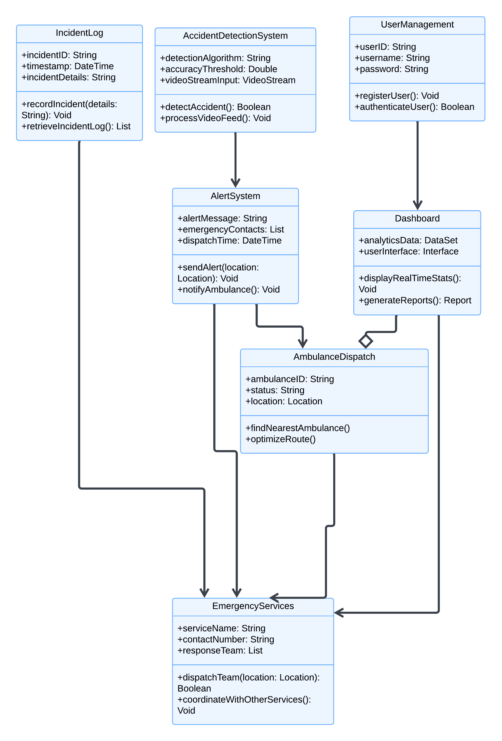

Entity Relationship Diagram

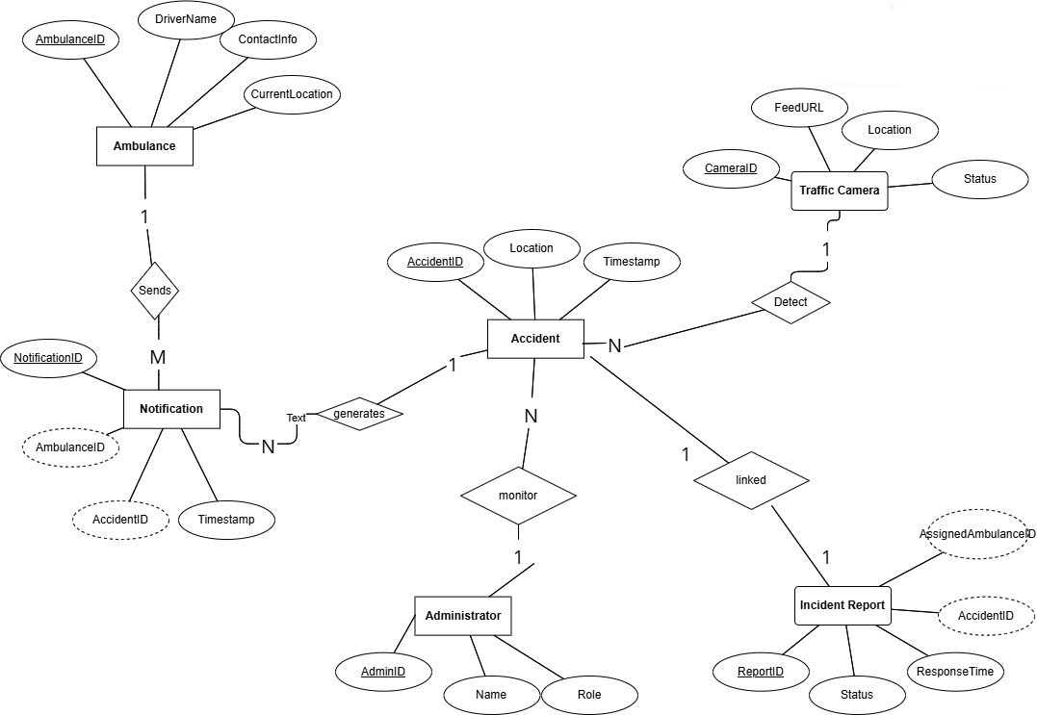

Sequence Diagram:

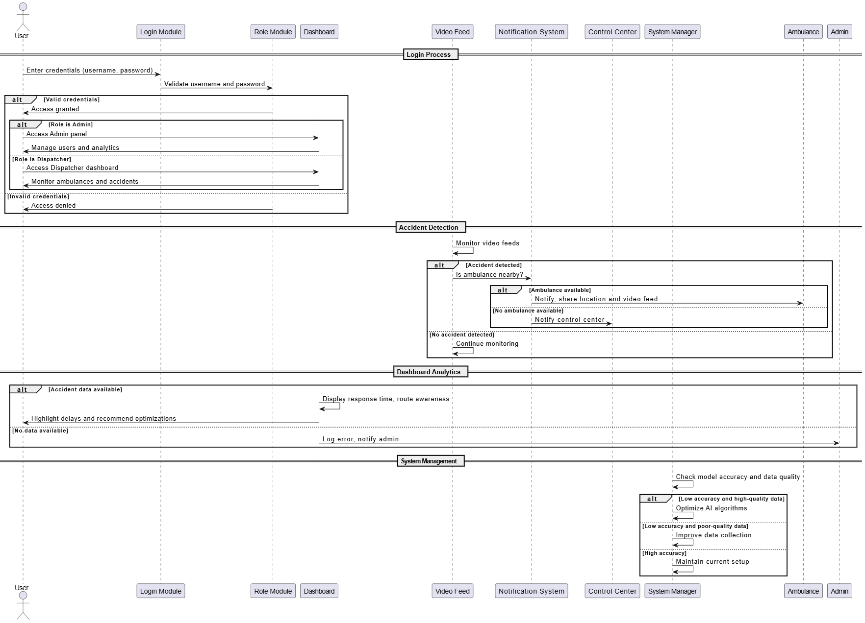

Data Flow Diagram:

Level 0:
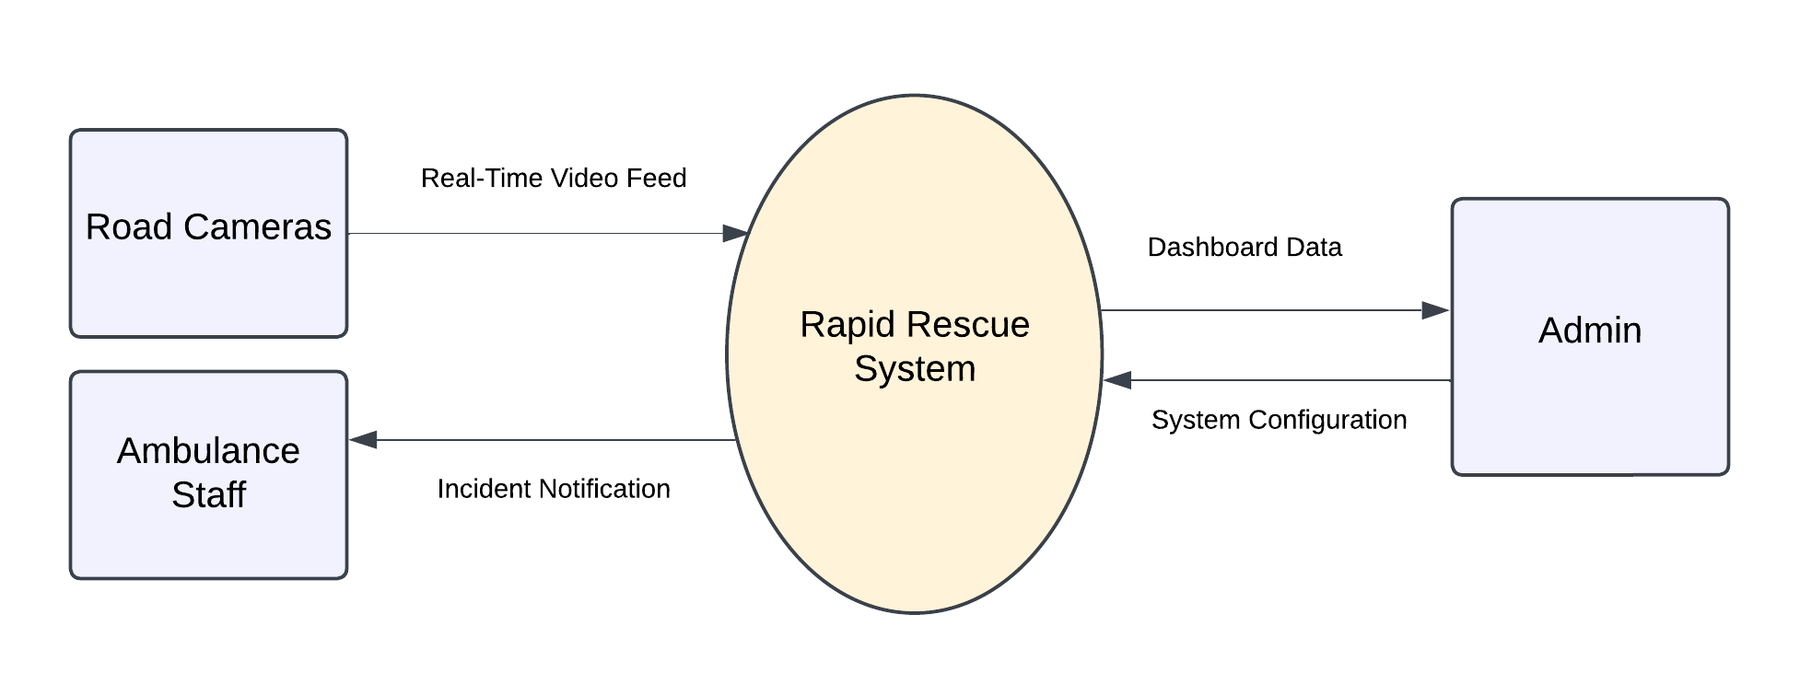

Level 1:
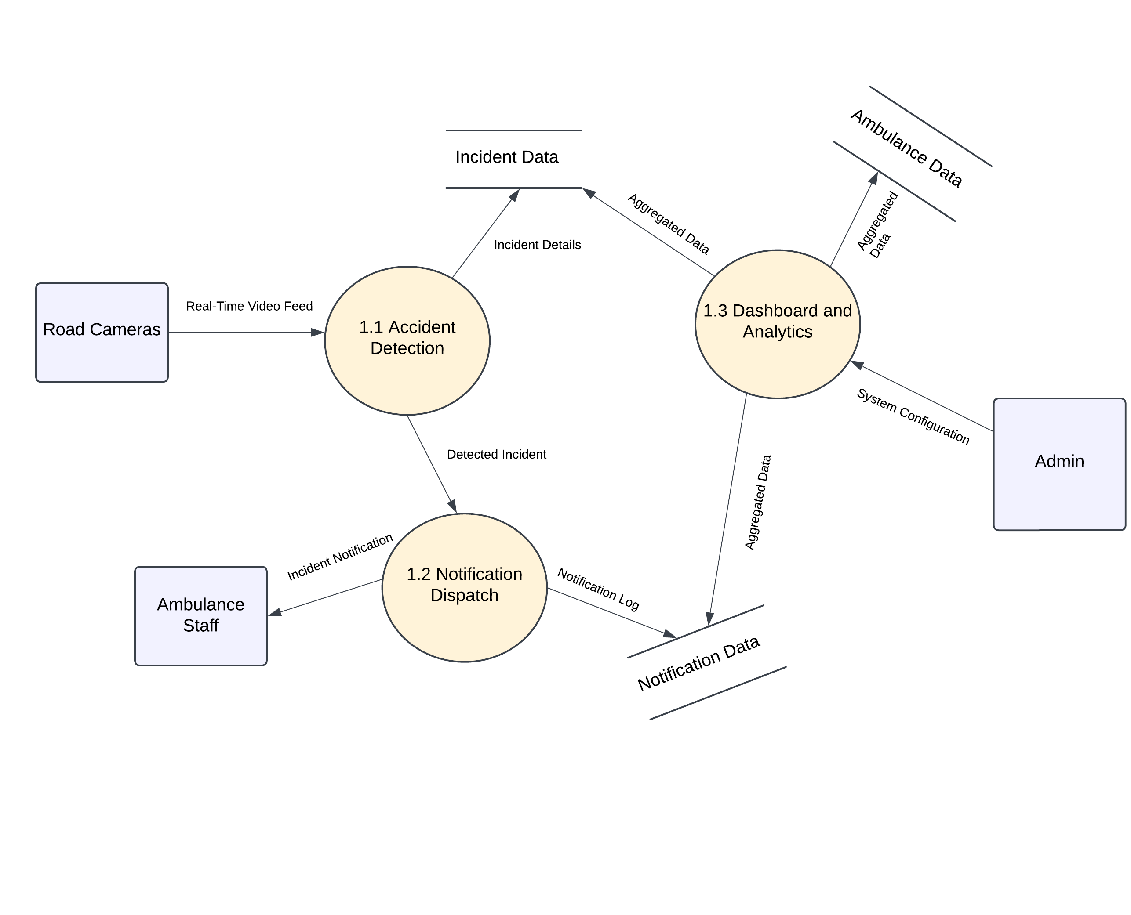

State Diagram:
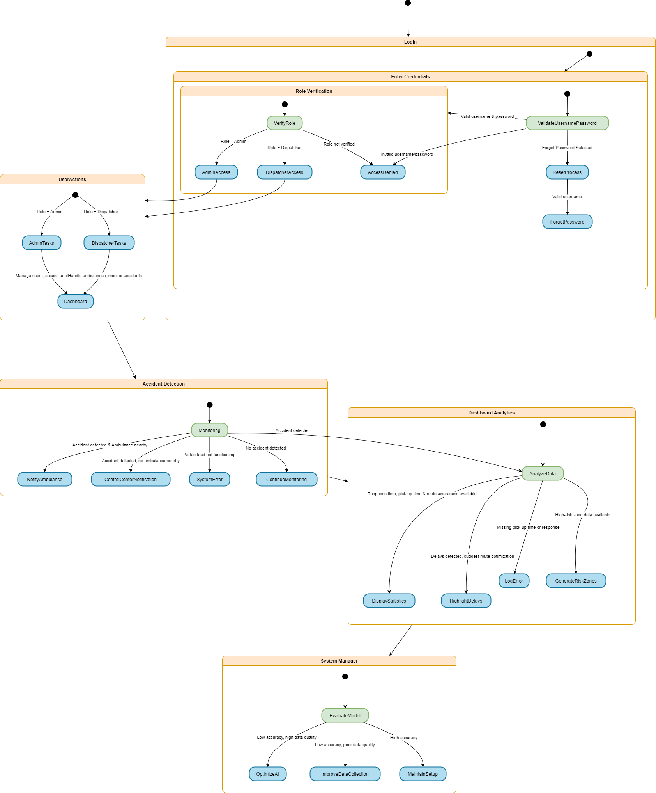

Decision Tables:

Decision Table for Login and Access:

EVENTS | 1 | 2 | 3 | 4
Valid Username | 1 | 1 | 0 | 1
Valid Password | 1 | 1 | 0 | 0
Role Verified (Admin/Dispatcher) | 1 | 0 | 1 | 1
Forgot Password Selected | 0 | 0 | 1 | 0
OUTCOME
Access granted based on role (Admin/Dispatcher) | 1
Access denied |  | 1 |  | 1
Password reset process initiated |  |  | 1

Decision Table for User Actions and Roles:

EVENTS | 1 | 2
Valid Username | 1 | 1
Valid Password | 1 | 1
Role (Admin) | 1 | 0
Role (Dispatcher) | 0 | 1
OUTCOME
Manage users, access analytics, Admin panel accessible | 1
Handle ambulances, monitor accidents, Dashboard accessible with alerts |  | 1

Decision Table for Accident Detection and Response:

EVENTS | 1 | 2 | 3 | 4
Video Feed Functioning | 1 | 1 | 0 | 1
Accident Detected | 1 | 0 | 0 | 1
Ambulance Available Nearby | 1 | 0 | 0 | 0
OUTCOME
Notify ambulance, share location & video feed | 1
Continue monitoring |  | 1
System error alert |  |  | 1
Notify control center |  |  |  | 1

Decision Table for Dashboard Analytics:

EVENTS | 1 | 2 | 3
Accident Detected | 1 | 1 | 1
Response time Available | 1 | 1 | 0
Pick-up time Available | 1 | 1 | 0
Route Awareness | 1 | 1 | 1
OUTCOME
Display statistics generate high-risk zones | 1
Log error, notify admin |  |  | 1
Highlight delays in dashboard, recommend route optimization |  | 1

Decisions Table for System Manager:

EVENTS | 1 | 2
Model Accuracy | 0 | 1
Data Quality | 1 | 0
OUTCOME
Focus on optimizing AI algorithms | 1
Prioritize improving data collection |  | 1

Nonfunctional Requirements

Performance Requirements
- Accident Detection Accuracy: It should report traffic accidents in real-time feeds with minimum false positives and negatives to send the emergency resources correctly dispatched.

- Real-time Alerts: The system should make and dispatch alerts from nearby ambulances within seconds of the accident to reduce the response time.

- Cloud Integration: This should be a cloud infrastructure that will accommodate low-latency processing so that communication and data transfer between different entities are carried out with minimal latency.

- Data Management: The system needs to manage and store large amounts of video data and accident-related information safely with minimal delays.

- Dashboard: The ambulance management dashboard should require real-time updating as well as analytics with virtually no delay in time for referring quickly to any information in current times.

- Reliability: The system must get location, route, and video feed data from ambulances without interruptions or breaks.

- User Experience: The video feed tools in the system and the dashboard must be user-friendly and responsive so that anyone using it won't find any difficulties.

Safety Requirements
And to ensure it doesn’t get false alarms, triggering needless dispatches of ambulances or worse, fail to detect emergencies, the system must be very accurate in pinpointing accidents. A system should deal with program failures or erroneous input data other than ruining the system reliability. The veracity of the information received requires that reliable video feed data and accurate transmitted alerts are provided and that the data is maintained in its integrity. Moreover, the system must work in real time, otherwise delays or disruptions will cause emergencies to be mishandled.

Security Requirements
Any data, whether it’s video feeds, location information or ambulance communication, must be encrypted both at rest and in transit to guard against unauthorized access to records of sensitive data. For specific functionalities, users must be authenticated, which must be robust to prevent only system admins and ambulance support staff from accessing. Asking for system features to be accessible only because of user roles, it would be wise to define access permissions through role-based access control (RBAC). However, all external API integrations must use secure protocols and must include authentication mechanisms to prevent anyone using them without authorization. The system takes care of core components: AI models and cloud infrastructure, and it needs to be secure from tampering or unauthorized modifying. For data safety, records of accidents and analytics of ambulances response should be stored in a secure, and access-controlled environment.

Additional Software Quality Attributes
- Adaptability: The system must perform well in different urban traffic and environmental circumstances.

- Availability: Minimal downtime is to be maintained during system operation.

- Correctness: Accuracy and consistency must be provided in accident detection and data reporting.
- Interoperability: In the best-case scenario, existing traffic cameras, GPS devices and such should be able to work with the system just fine.

- Maintainability: In modular design update and issues resolution have to be done efficiently.

- Reliability: It is necessary that the system performs continuously under the conditions of real time and the loads are expected.

- Usability: Ambulance staff as well as administrators should find interfaces intuitive.

Other Requirements
Efficiently securing accident records, ambulance details and analytics data as well the ease of quick real time data retrieval and scalability to the increased data loads. It has to integrate external interfaces such as traffic cameras for video feeds, ambulances GPS devices, routing into Google Maps and Firebase notifications. Ideally, it should enable internationalization for regional languages and localized measurement systems for non-uniform population. Moreover, the system should fulfill local video surveillance and data privacy rules for the sake of legality. The system is designed to be modular, such that it can be adapted for other emergency response services that may reuse and scale to broader applications.

Revised Project Plan
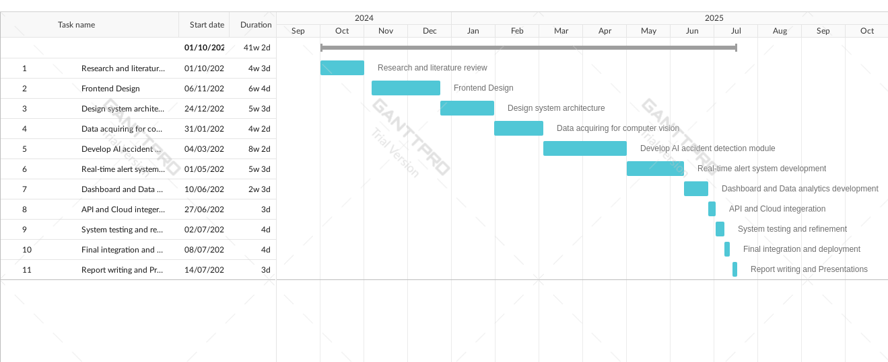

References
- Kamran and Haas (2007) present a multilevel approach using GPS data.
- Škorput et al. (2012) propose a real-time detection system based on road traffic incidents.
- Ksiksi et al. (2015) focused on intelligent traffic alert systems in smart cities.
- Sadaphal (2019) developed an Android-based detection and alert system.

https://app.diagrams.net/

Appendix A: Glossary
A – Glossary
AI (Artificial Intelligence): Thinking and acting like people is programmed into machines programmed to simulate human intelligence.
API (Application Programming Interface): A collection of functions and procedures that permit systems from different computing worlds to interact.
C – Glossary
Cloud Computing: The ability to offer storage and processing power over the internet.
Computer Vision: AI Filed about allowing the machines to understand and choose using visual data.
D – Glossary
Dashboard: A web interface used by ambulance services to monitor real time data and analytics around emergency responses.
Data Analytics: The activity of unravelling datasets to glean useful insights, trends and patterns.
E – Glossary
Emergency Response System: System designed to be coordinated and respond immediately to road accidents.
G – Glossary
GPS (Global Positioning System): Navigation system using satellite to supply location and time information.
P – Glossary
Prediction Accuracy: The capacity to correctly identify or predict specified events like accidents.
R – Glossary
Real-Time Analytics: The real time (or semi real time) analysis of incoming data so business outcomes can be derived while the data is being gathered.
S – Glossary
Scalability: The ability of a system for increased workload or expansions without loss of performance.
Streaming Video: Video data transmitted continuously from a source (traffic cameras) to a receiver (ambulance systems).
T – Glossary
Traffic Cameras: They provide high-definition cameras located all over the road to monitor traffic flow as well as detect accidents.
U – Glossary
Urban Safety: Measures and systems in the place to protect people in the densely populated area, like the city.
User Roles: Enforced access levels and permissions for people touching the system, for example, or ambulance staff or administrators.

Appendix B: IV & V Report
(Independent verification & validation)
IV & V Resource

Name Signature

S# | Defect Description | Origin Stage | Status | Fix Time
 |  |  |  | Hours | Minutes
1
2
3
…
Table 2: List of non-trivial defects

